|  |  |
| --- | --- |
| **1.Javascript - Introduction to JavaScript** | **Date: 13-16-2023** |

**Topics**

## What is JavaScript, JavaScript History, How JavaScript Works, JavaScript and Java Same, Advantage and Disadvantage of JavaScript

## **What is JavaScript?**

JavaScript is the programming language of HTML and the Web. It makes web page dynamic. It is an interpreted programming language with object-oriented capabilities.

## **JavaScript History**

• 1995 by Brendan Eich (NetScape)

• Mocha

• LiveScript

• JavaScript

• ECMAScript

## **How JavaScript Works?**

Javascript mein server se html,css,js ajati hai jab user request karta hai or user ke end per wo sara code fir execute hota hai, line by line.

Php mein code server per hi execute ho jata hai yahan aisa nahi hota hai

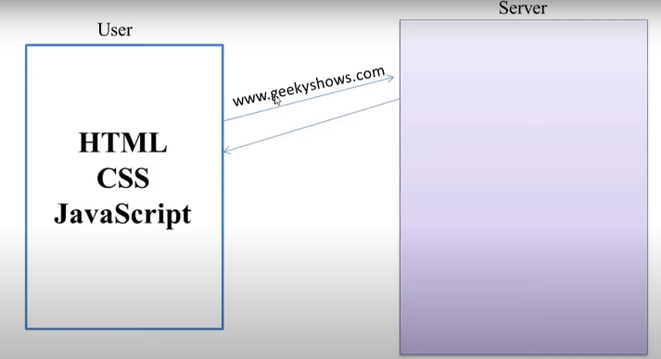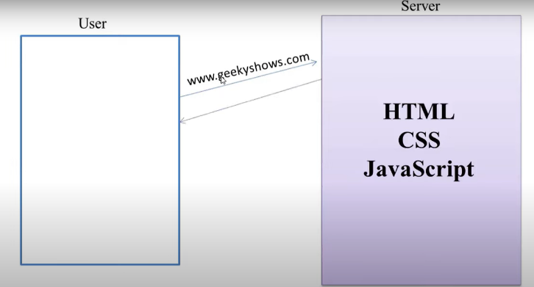

## **JavaScript and Java Same?**

No, Java language is more popular at that time that’s why they keep java and include in JavaScript, to get more popularity.

## **Advantage and Disadvantage of JavaScript**

**Advantage of JavaScript**

* Client Side Execution - JS ka code client side per execute hota hai, toh ise server per kam load ata hai which makes js faster.
* Validation on Browser - Validation forms input ka client side per hi kar sakte hai js ki help se, use benefit yeh hai ki koi user ne galti ki hai toh use usi waqt pata chal jata hai bina server per request jaye, ise data bandwidth mein bhi saving hoti hai ki apka data bina validate hoke ja hi nahi raha hai server per.
* Easy Language – Easy Syntax

**Disadvantage of JavaScript**

* Less Secure - less secure because client side per code execute hota hai and many other issues.
* No Hardware Access - cant be access hardware, file system of machine etc.